

**MONTHLY TEST JUNE 2019**

|  |
| --- |
| **Marks obtained:** |
| **Total:**  **25** |

**Name: ____________________________**

**Grade: I Section___**

**Subject: EVS**

**Date: 28 .6.18**

**Time: 1 Hour**

**I. Name the Parts of the body. 5 X 1 = 5**

**Ears, Hands, Mouth, Eyes, Nose**

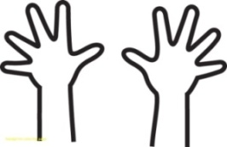 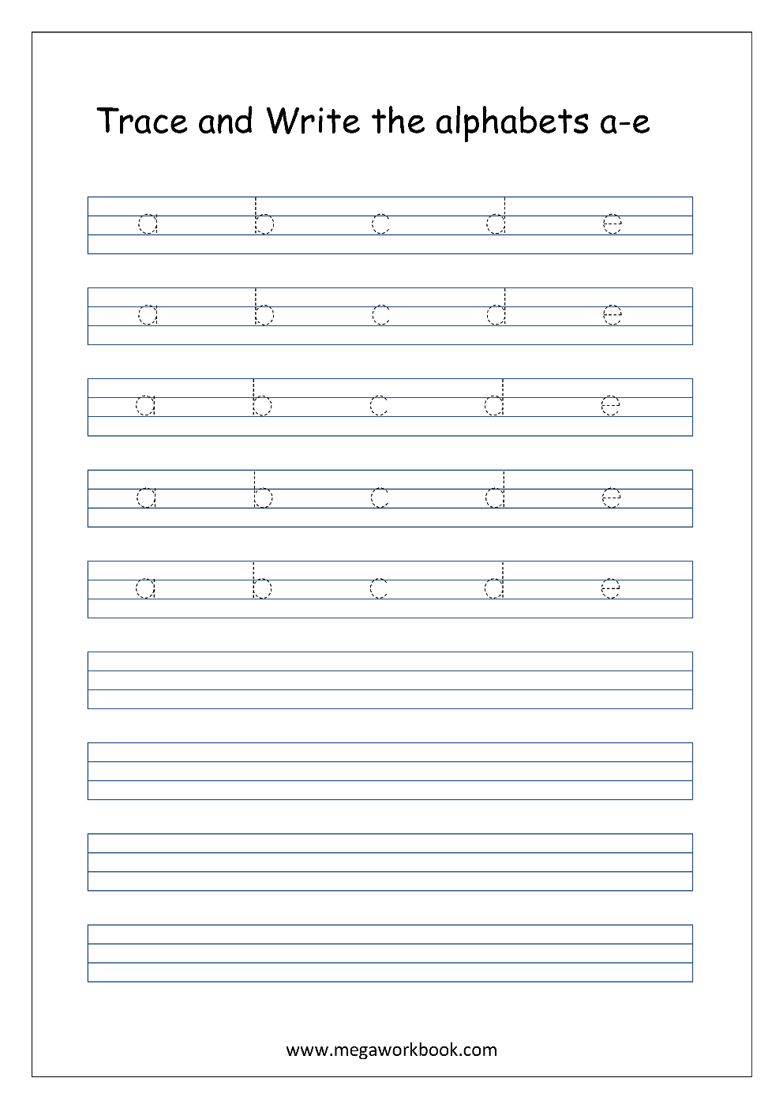

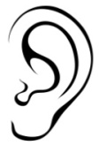 

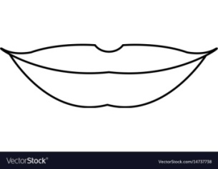 

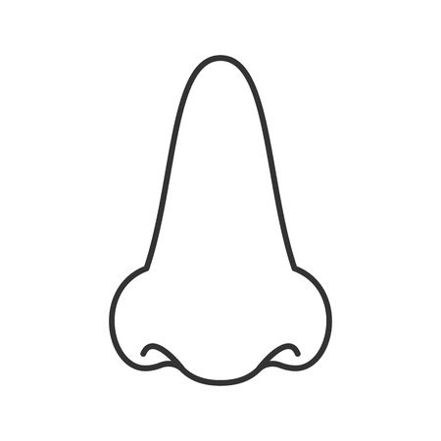 

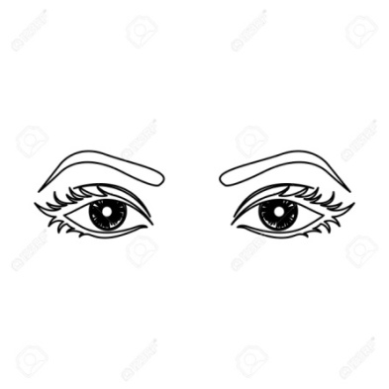 

**II. Match the following. 4 X 1 = 4**

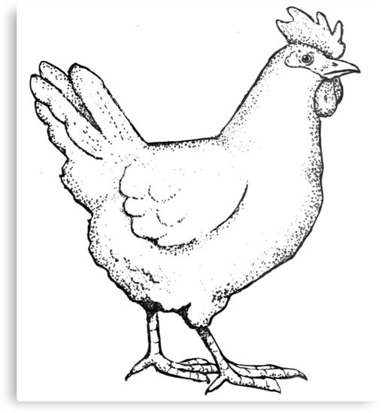 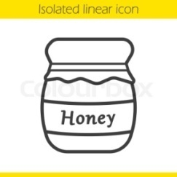

**Hen**

**Bee**

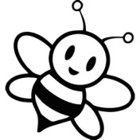 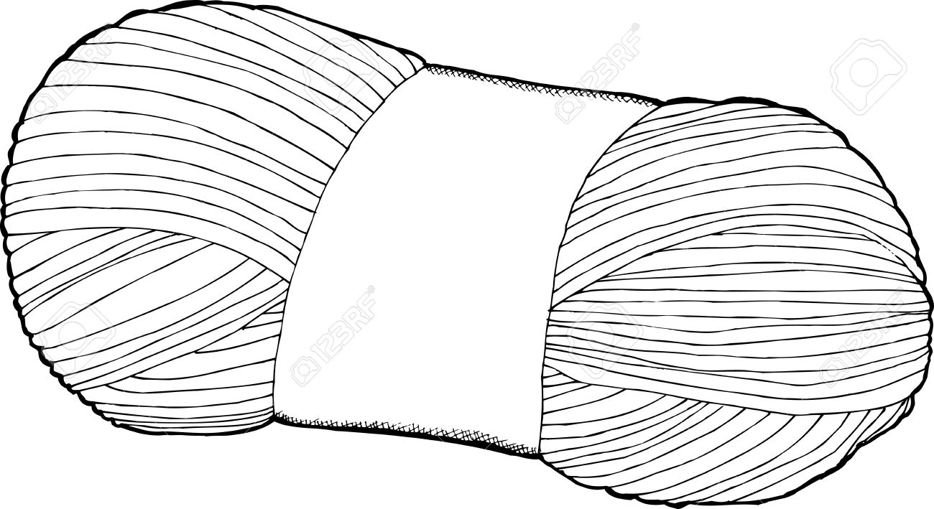

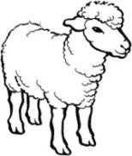 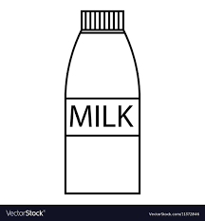

**Cow**

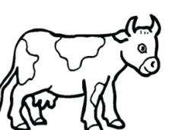 

**Sheep**

**III. Circle the wild animals. 5 X 1 = 5**

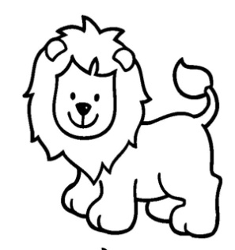 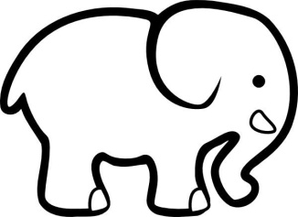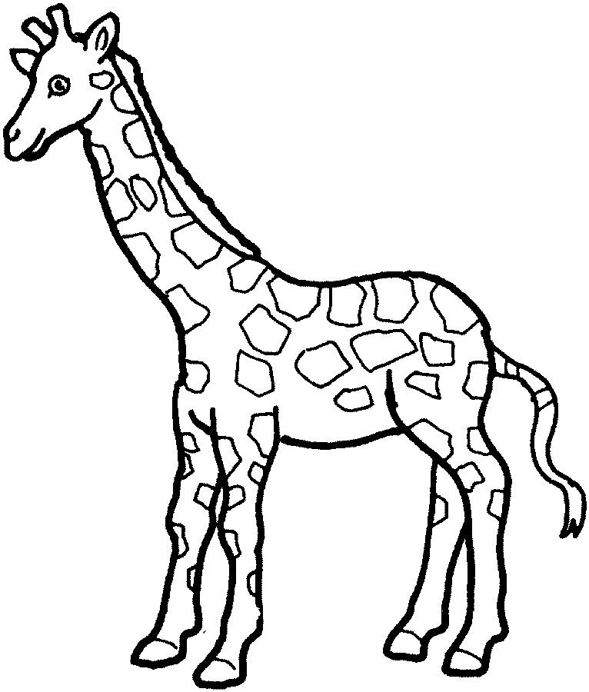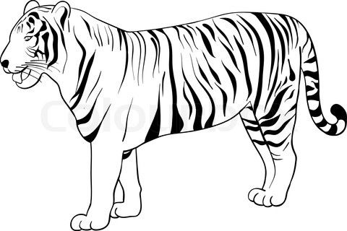

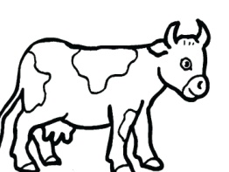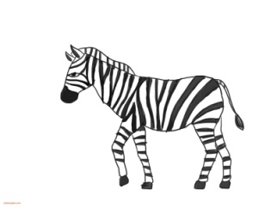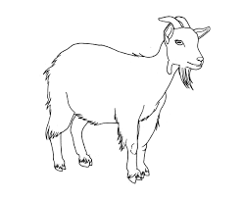

**IV. Put a tick for good habits and a cross for bad habits.**

1. Taking bath daily.

2. Not clipping nails.

3. Brushing teeth twice a day.

4. Running in the class.

5. Washing hands before eating.

6. Not helping your friend.

**V. Fill in the blanks in the clouds. 2x1=2**

My name is

______________________________

The name of my school is

__________________________________

**VI. Draw your favourite fruit and colour it. 2**